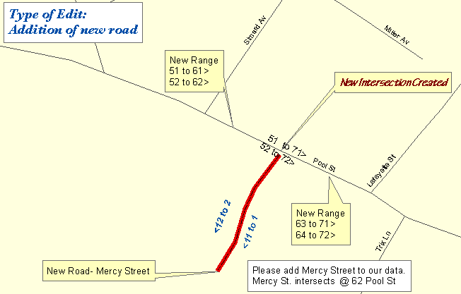

One Maine Enhanced 9-1-1 Update Form will need to be filled out for the above edit. The following sections are found on MSAG Update Forms and serves as an example as to what information needs to be provided to Emergency Services Communications Bureau/GIS in order to complete the edit. In addition, please provide all the information noted on the map above by marking it on a copy of the map book page. Please submit both the map book page and the Update Form to Emergency Services Communications Bureau/GIS.

FORM 1

- □ A. New Street : |  |  | Effective Date: 1/23/2003
1. Street Name: Mercy St | 5. Number range: low_1_ high_12_
2. Closest Intersecting Street: Pool St | ___odds _x_ evens ___both
3. Address Off Intersecting Street: 62 Pool St
4. Addressing Interval: |  | - 25 ft. |  |  | - 50 ft. | - Other
- □ E. Address Range Change | Effective Date: 1/23/2003
Street Name: Pool St
Reverse direction of numbering | Reverse odds/evens
Number range change: ___Odds ___Evens ___Both
Old range: low __51_ high_72_
New range: low __51__ high 62__

Remarks: intersection range change between Simard and Mercy St

- □ E. Address Range Change | Effective Date: 1/23/2003
Street Name: Pool St
Reverse direction of numbering | Reverse odds/evens
Number range change: ___Odds ___Evens ___Both
Old range: low __51___ high_72__
New range: low __63___ high_72__

Remarks: From Mercy St to Lafeyette St

